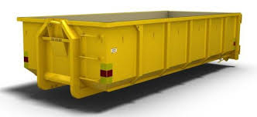
Containers for solid waste will be set up in the courtyard from 6th November to
11th November 2024.

Examples of solid waste:
• Furniture
• Sleds
• Toys
• Bicycles
• Prams
• Frying pans, pans, porcelain and smaller ceramic items
• Flowerpots

The following items are not considered solid waste:
• Kitchen fittings and doors
• Toilet seats, sinks, bathtubs and tiles
• Concrete and plaster
• Electrical waste
• Car and bicycle tires
• Spray, paint, glue, silicone
• All types of oil

Other solid waste must be left at Görväln's Recycling Center SÖRAB (Återvinningsvägen)
Opening hours: Monday-Thursday at 12.00-20.00 and Friday-Saturday at 09.00-16.00.

Greetings, The board

